Capstone Report

MCG4322A: PSF4

Due: December 10th, 2021

Abstract

Due to the smoke produced by forest fires, residents in the surrounding areas are compelled to seal all windows and doors of their homes to limit smoke from infiltrating the house. This causes temperatures within the home to rise to undesirable temperatures. Additionally, the damage due to wildfires can cause widespread power outages, so external power is not always available. The goal of this project was to provide a parametrically scalable system that both cleans and cools the air while also being able to operate with no external power. The proposed solution filters particulate matter that is 2.5 microns in size or less and smoke odours out of the air and cools the air in the home down to comfortable temperatures. It has an upright cylindrical design that captures air from 360 degrees, and it sits on the floor with wheels for portability. It requires access to an exterior window where the window kit can be installed to exhaust the heat to the outdoors and has a 30 Ah battery that allows for limited use during a power outage. The unit can be parameterized to remove heat at 500W to 1500W by changing the coil geometry.

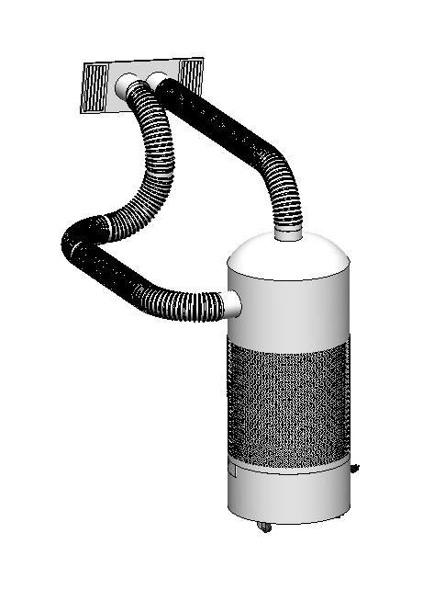

Table of Contents

1 Project Charter 1

1.1 Mandate 1

1.2 Requirements 1

1.3 Constraints 1

1.4 Criteria 1

1.5 Parameterization Outline 1

2 Proposed Design 2

2.1 Overview of solution 2

2.2 Operation 8

2.3 Process of assembly 8

2.4 Component breakdown 9

2.4.1 Bottom block 9

2.4.2 Vertical posts 10

2.4.3 Brackets 10

2.4.4 Circular Plates 10

2.4.5 Blower mountings 11

2.4.6 Casing 11

3 Parameterization 11

3.1 Component optimization and discussion on results 12

4 Discussion and critical review 14

5 References 16

A. Instructions for running GUI 18

B. Component parameterization flowcharts 18

C. Design code 22

D. Datasheets 23

E. Additional material 38

Drag force on the filter 38

Pressure losses in the duct system 39

Blower 1 40

Blower 2 41

List of Figures

Figure 1: Front view of the system with casing removed 2

Figure 3: Evaporator coil bank with one filter released 3

Figure 4: Support plate holding the compressor and evaporator coil 4

Figure 6: Condenser blower mounted to support plate 4

Figure 5: Condenser coil bank 5

Figure 2: Base block with battery plate removed 6

Figure 7: Window kit with ducts attached 7

Figure 9: Flow-chart of the entire system 12

Figure 10: Airflow path of evaporator coil 3

Figure 11: Characteristic curve for blower [8] 4

Figure 12: Airflow path for condenser coil 4

Figure 13: Friction loss data for 4" flexible duct [9] 5

Figure 14: Geometric relation for friction losses in duct bends [9] 6

# Project Charter

## Mandate

The occurrence of wildfires has been increasing in regions where temperatures reach highs of 35C during the summer and fall seasons. These wildfires emit a potent pollutant called fine particulate matter, also known as PM2.5, which is known to cause severe cardiovascular and respiratory diseases. To avoid breathing in these particulates, public health advice includes living in a closed-off space, where windows and doors are shut and sealed. Unfortunately, many households do not own air conditioning in the regions where these wildfires persist, making internal temperatures exceptionally high. These households do not have air conditioning because they are often too expensive or unavailable.

## Requirements

To combat this issue, a portable air filtration system is designed that must be able to filter PM2.5 from the air while cooling the air to a comfortable living temperature. This system must also have the ability to continue running when no external power is available.

## Constraints

This unit is designed to operate in North America and must therefore be compatible to run from the standard plug, a type B socket that supplies 120 V at 60 Hz.

## Criteria

The cost of the filtration system must be competitive compared to the overall market. The number of parts should be minimized to improve the simplicity of assembling and ease of set-up. It must be stable enough to not tip over with a small amount of force and must be durable enough to withstand some knocks in transportation. Finally, it must be small enough and light enough to be portable from the store to the home and from room to room within the home.

## Parameterization Outline

**Geometry of the room:** The layout of the room, including wall and window surface area and the number of exterior doors, will influence the heat infiltration rate of the room. This parameter will drive the coil size and geometry.

**The initial and desired indoor air temperature:** The temperature of the air coming into the system from the room will influence the evaporator coil size and length, and the difference between the initial and desired room temperature will affect how long it takes to cool the room.

**The outdoor air temperature:** The temperature of the air coming into the system from the outdoor will influence the condenser coil size and length.

**Number of occupants:** The number of people in the room will influence the coil size and geometry.

# Proposed Design

## Overview of solution

A view of the entire system with the case removed can be seen below.

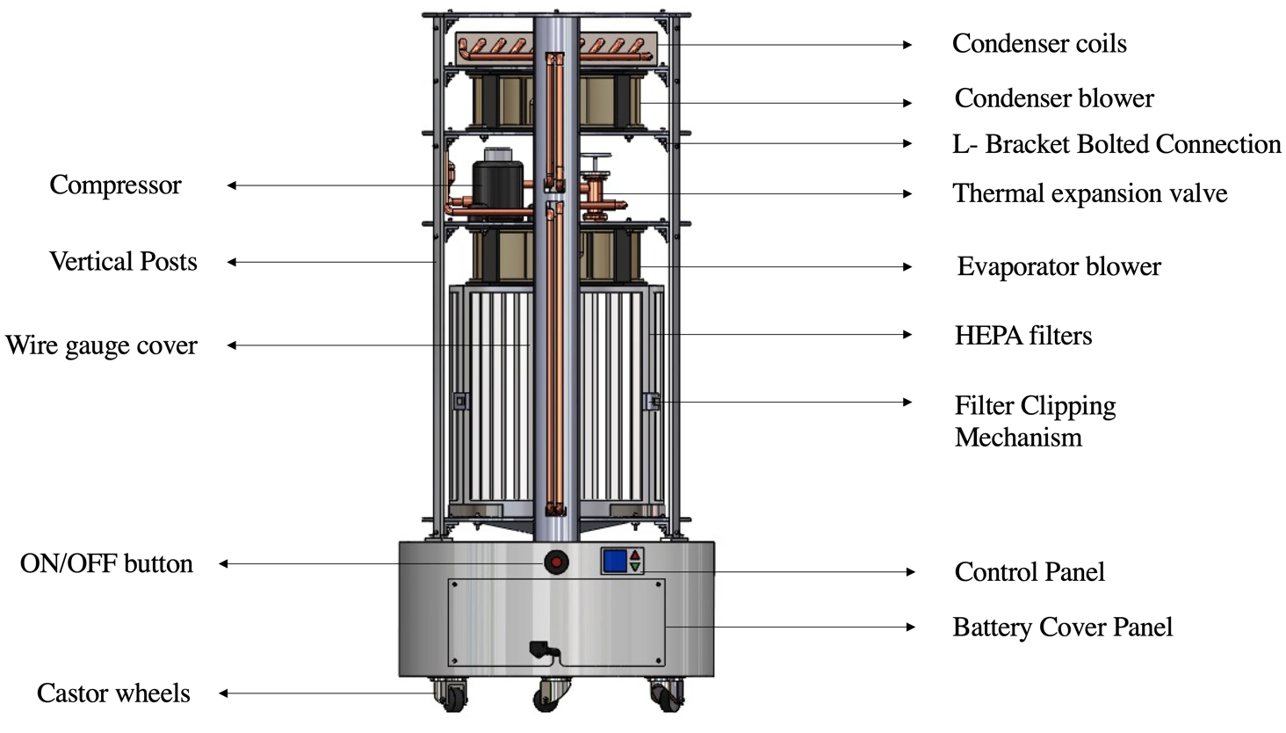

Figure : Front view of the system with casing removed

The solution uses two centrifugal blowers to move the air throughout the system. These are labelled evaporator and condenser blowers above. The evaporator blower draws air through the casing mesh and into the filters in the lower section. This can be seen in the figure below.

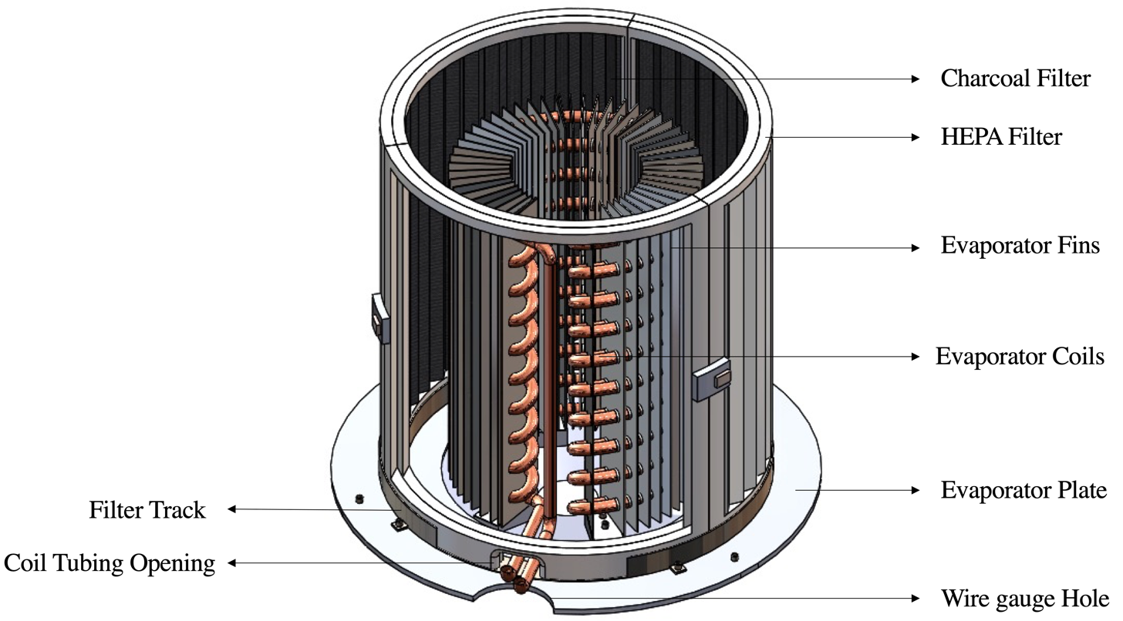

Figure : Evaporator coil bank with one filter removed

From here, it moves through the evaporator coil and into the blower. The cold, clean air is then ejected back out at 360 degrees through the casing mesh. The refrigerant tubing carries the refrigerant through the evaporator coils, where it is heated from a vapour liquid mixer to saturated vapour. It then enters the compressor and exits a superheated vapour when entering the condenser coils. A detailed view of this path is shown below.

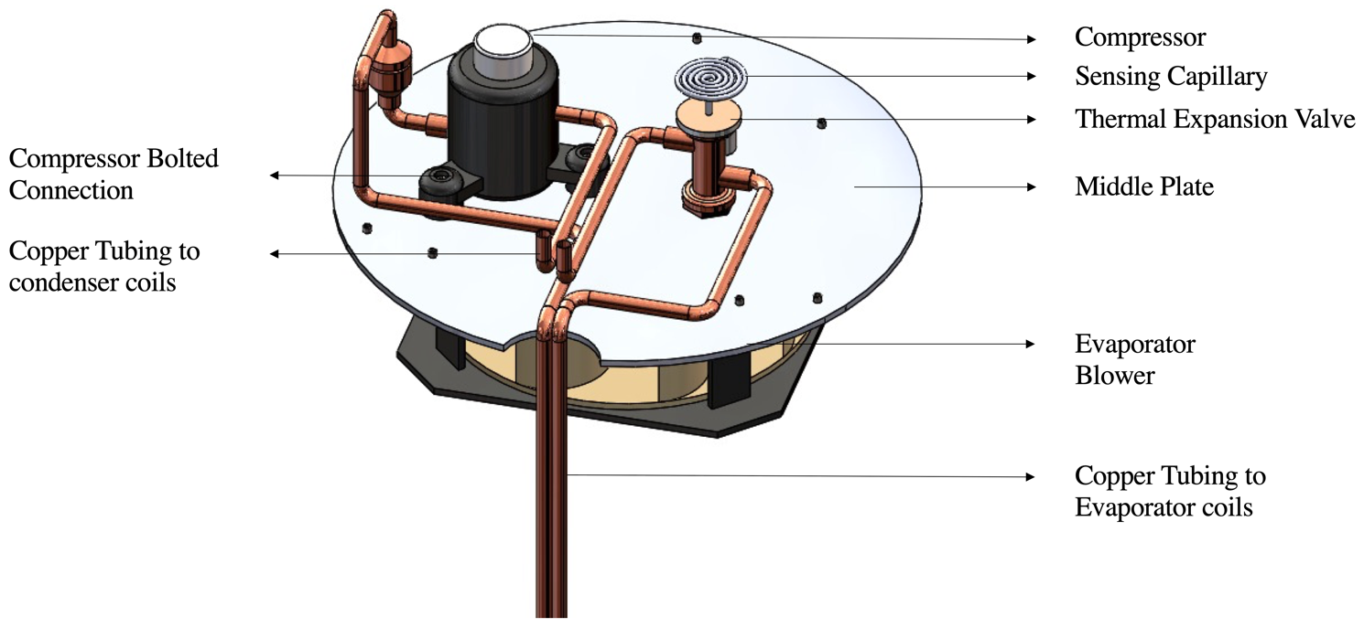

Figure : Support plate holding the compressor and thermal expansion valve

The condenser blower draws in air from the outside through the inlet duct on top of the unit, pulls it over the condensing coils and ejects it out through the outlet duct to the outdoors. This cools the super-heated refrigerant to a saturated liquid when it enters the thermal expansion valve. These two sub-assemblies are shown below.

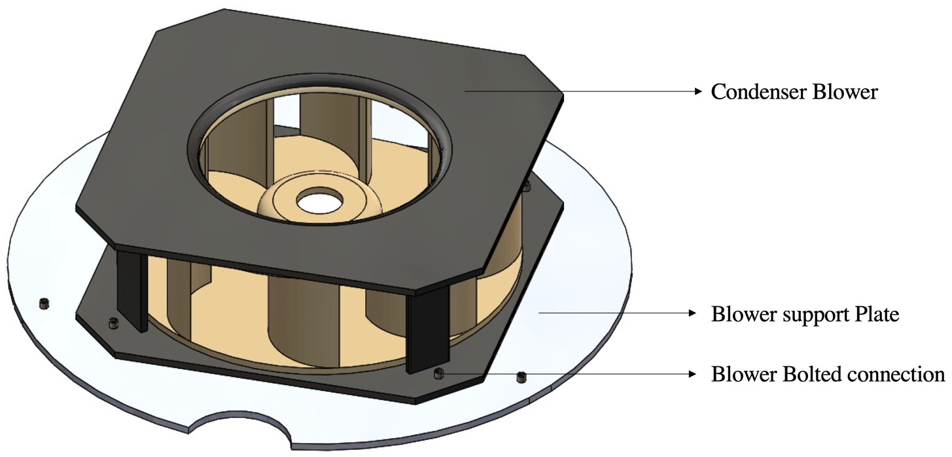

Figure : Condenser blower mounted to support plate

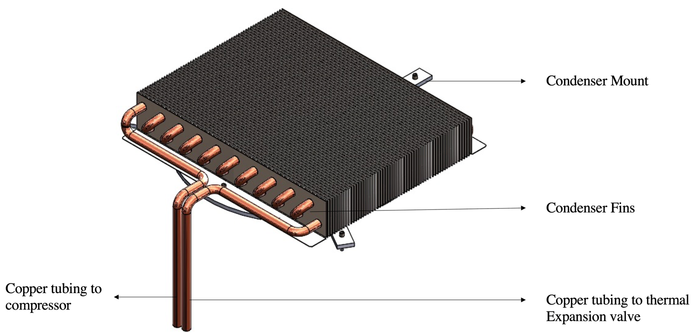

Figure : Condenser coil bank

The thermal expansion valve drops the pressure of the refrigerant, making it much cooler than the air in the room, and it then enters the evaporator coil a mixture. The cycle then repeats continuously, ejecting cold, clean air into the space and hot air into the outdoors. A battery in the base block powers the blowers, control panel and compressor. The figure below shows this sub-assembly.



Figure : Base block with battery plate removed

The wires run up through the wire gauge hole into a channel created by the wire gauge cover and the casing. The battery is connected to a converter with a power cord that connects to a nearby outlet. The battery is accessible via the battery cover panel, which is easily removed, as shown above. As indicated above, the base block also houses the condensation drawer, which can be slid out and emptied. The control panel allows the user to set the desired room temperature.

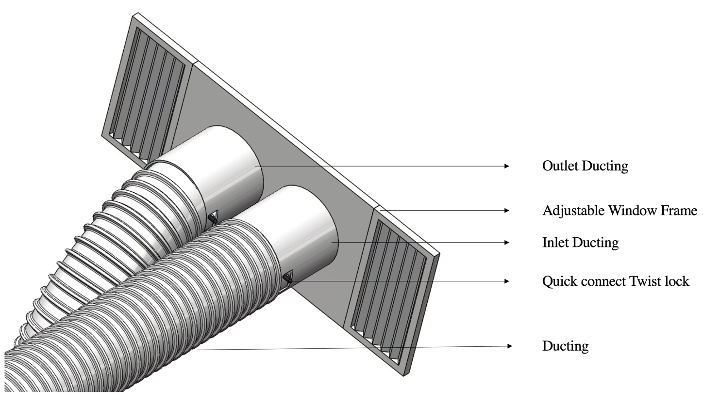

Figure : Window kit with ducts attached

The figure above shows the window kit assembly, which features the quick connect twist lock for the ducts and an accordion system that adjusts different sized windows. This kit can be installed horizontally or vertically, depending on the window design. To access the coils the casing is slid up and off of the. It has groves on the inside that match that of the unit so ensure a proper fit between the casing and the system. This is shown in the figure below.

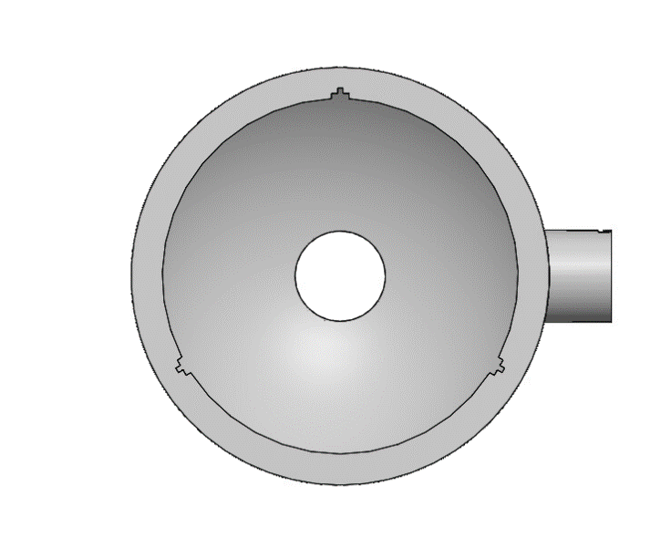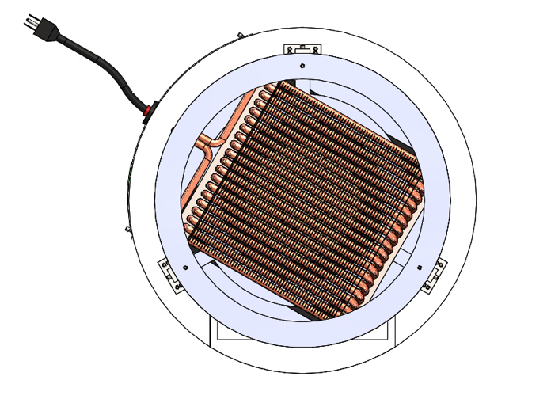

Figure : Inside of casing and how it fits over the unit

## Operation

The unit is simple to operate, and maintenance is user-friendly. The user plugs in the system, presses the ON button, sets the desired temperature, and both the cooling and air filtration system run automatically. The user can slide the bottom drawer out to dump any condensed water. To change the filter, the casing is removed, and the filters can be lifted out of their groves and swapped for clean ones. If the power were to go out, the unit would continue to run until the battery was dead. The filters should be renewed every eight months.

## Process of assembly

The system is assembled from bottom to top, starting with the base block. The base plate will include the water collection drawer and the battery. The battery will be connected to the blowers in parallel to increase the amp-hour battery capacity. The drawer will slide into its compartment using groves to ensure the drawer will be held in place. The next step will be to assemble the wheels to the bottom base block.

After the base block is assembled, the next step will be to install the vertical posts. The vertical posts will be bolted to the base block using two bolts that thread into the base block on either side of the post. Once all three vertical posts are secured, the internal components and their respective support plates can be installed. The process for each layer is the same, starting with fastening the brackets to the post, the plate to the brackets and finally securing the component to its respective plate. The first plate to be installed is the evaporator support plate. This plate has a small opening at its bottom to allow the water to drip from the coils into the drawer below it. Once secured in the frame, the coil bank can be placed from the top and fastened to the plate. The second plate holds the evaporator blower, the thermal expansion valve, and the compressor. These components should be affixed to the plate first, followed by securing the plate to the posts. This will allow for easier access to the blower fasteners. The exact process is used for the next plate, which holds the condenser plate. The condenser support plate is now installed, and once it is fixed in place, the condenser coil bank can be placed into the unit from the top and its fasteners secured. A ring is then attached to the top of the three posts to provide stability and support to the frame.

Now that all the refrigeration components are in place, the tubing must be charged with refrigerant fluid. This requires a refrigerant charging kit with gauges to ensure proper pressure in the tubes. The refrigerant in this system is R-134A. Once the refrigeration cycle is completed and sealed, the filters can be placed in their tracks and clipped together, and the casing can be placed over the unit. The ducts are connected via a quick twist-snap system to the unit and the window kit.

## Component breakdown

The design solution consists of the following major components.

Table : Major design components and their properties

|  |  |  |
| --- | --- | --- |
| Part | Material | Yield strength |
| Bottom block | Aluminum 6061 | 241 MPa [1] |
| Vertical posts | Aluminum 6061 | 241 Mpa [1] |
| Brackets | Aluminum 6061 | 241 Mpa [1] |
| Circular Plates | Aluminum 6061 | 241 Mpa [1] |
| Blower mountings | Polypropylene | 33 Mpa [2] |
| Casing | Polypropylene | 33 Mpa [2] |

These parts are designed by identifying the characteristics of the application and choosing the required materials based on the component's specifications. The material selection factors include availability, cost, material properties, manufacturing processes and stress analysis [3].

### Bottom block

The purpose of the bottom block is to contain the battery and the drip pan drawer where the condensate from the evaporator coil falls from above. The bottom block is made from aluminum 6061 material because aluminum is a prevalent material used in many modern industrial processes making it widely available. The cost of aluminum is relatively cheap compared to other materials such as steel and tungsten. A cost graph can be seen in Appendix E.

Thus, making aluminum an optimal choice to reduce the overall costs of the system. The mechanical properties of aluminum offer good strength to weight ratio for the application and are corrosion-resistant when exposed to air and water [4].

The manufacturing processes selected is casting because it is the cheapest and can create simple or complex parts containing internal cavities using a steel core. The casting process depends on the number of parts being produced. If the number of parts being manufactured is under 20,000, sand casting is selected, but if the number of parts is above 20,000, then die casting is selected [3]. It can be assumed that these units would be produced on a large scale for consumer purchase, so die-casting would likely be used. Additionally, sand casting does not offer a smooth surface finish and would require additional machining.

### Vertical posts

The purpose of the vertical posts is to give the system a strong structure so that other components can be attached to them. The vertical posts will be made from aluminum 6061 for the same reason as the bottom block, which offers an excellent strength to weight ratio and other mechanical properties. The vertical posts will be manufactured using an extrusion process, forming a simple rectangular shape as a cross-sectional area. The extrusion will then be cut to length using a saw giving three identical posts, and then the holes will be drilled using a metal drilling tool according to the bolt hole size, and a total of 4 holes will be drilled in each vertical post.

### Brackets

The purpose of the bracket is to support the weight of the plates, coils and any other components sitting on the plates. Three brackets support each circular plate. The material selected is aluminum 6061 for the above-justified reasons. The brackets used will be extruded from a die and then cut to a length using a saw. The holes will then be drilled using a drilling tool to a size of 3.5mm on each leg of the bracket.

### Circular Plates

The plates will be used to carry the weight of the coils. They will also be made from aluminum 6061 for the above-justified reasons. The plates will be manufactured using aluminum sheets big enough to accommodate three full plates and the circular ring at the system’s top. The process will include starting from an initial flat aluminum sheet of thickness 2mm, and blanking will be used to cut the aluminum sheet to size. The circular plates will have three holes drilled into them using a metal drill bit to connect the brackets. The plates will also have a semicircle cut from them on one side for the coil tubing and wiring to be directed to the appropriate positions.

### Blower mountings

The purpose of the blower mountings is to hold the blowers in place. The blower mountings will be made of polypropylene material since it is relatively inexpensive and has an excellent flexural strength because of its semi-crystalline structure. It is also very resistant to moisture [5]. The manufacturing process used to mould polypropylene will be injection moulding. This is because polypropylene is a prevalent material to mould since it flows very well due to its low melt viscosity, thus enhancing the rate at which the mould gets filled [6]. This process is usually expensive, especially for the few parts produced, but the price per part can be reduced significantly for many parts.

### Casing

The purpose of the casing is to protect and shield the internal components of the design from any external threats. The selected material is Polypropylene since it has excellent flexural strength while being relatively lower in cost than an aluminum casing seen in the figure in the appendices [3]. Another reason for selecting polypropylene as a material is that it is lightweight in terms of mass compared to aluminum while still offering a good impact strength for when dropped or knocked over [6]. The manufacturing of the casing will be done using injection moulding since the material polypropylene is easy to mould. The case includes groves to fit firmly onto the unit without any movement.

# Parameterization

The parts being structurally parameterized in this system are the following:

* Evaporator support plate
* Condenser support plate
* Evaporator coil and fins length
* Condenser coil and fins length

The flow chart showing the complete parameterization process is shown below.



Figure : Flow-chart of the entire system

## Component optimization and discussion on results

Table : Component optimization summary

|  |  |  |
| --- | --- | --- |
| **Assembly** | **Component** | **Optimization** |
| Evaporator coil | Number of rows | 18 < Nrows < 35 |
| Evaporator fins | Length | 181.4 mm < Levap fin < 357.8 mm |
| Condenser coil | Number of columns | 13 < Nrows < 19 |
| Condenser fins | Length | 172 mm < Lcond fin < 250 mm |
| Condenser plate | Thickness of plate | 2 mm < tcond < 5 mm |
| Evaporator plate | Thickness of plate | 2 mm < tcond < 5 mm |

The most significant results can be seen in the evaporator and condenser coil size. This is shown below.

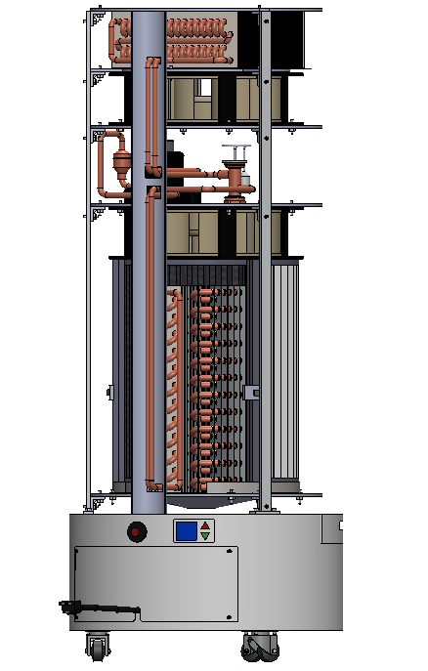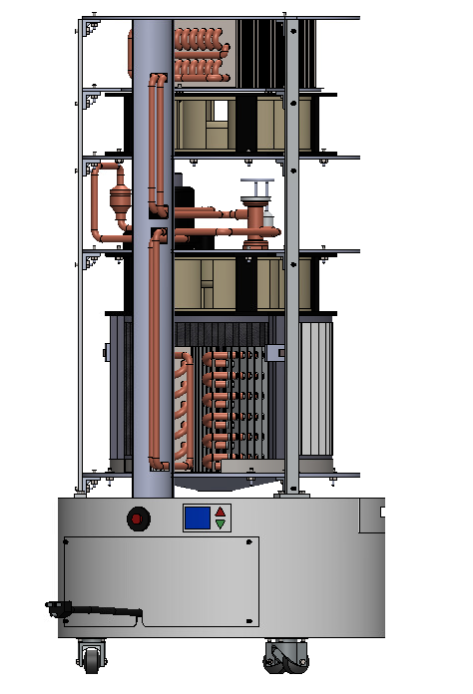

Figure : Large vs small unit

As the evaporator coils get larger the filters also change in size to match the surface area of the inlet. This is shown above. On the left is the largest the unit is designed to be and it has the ability to output 1.5kW of cooling power. On the right is the smallest the unit is designed to be and it outputs 500W of cooling power. The change in the size of the condenser coil can be seen below.

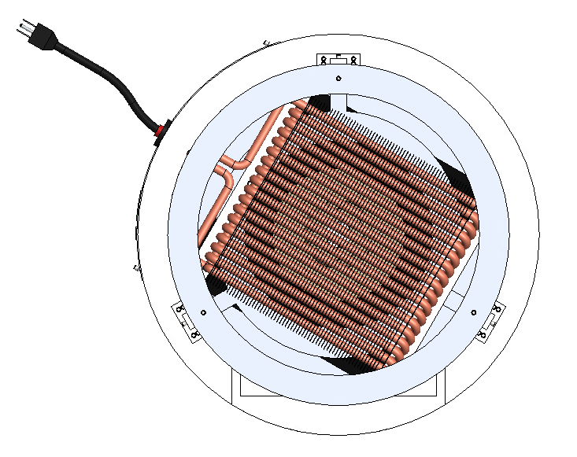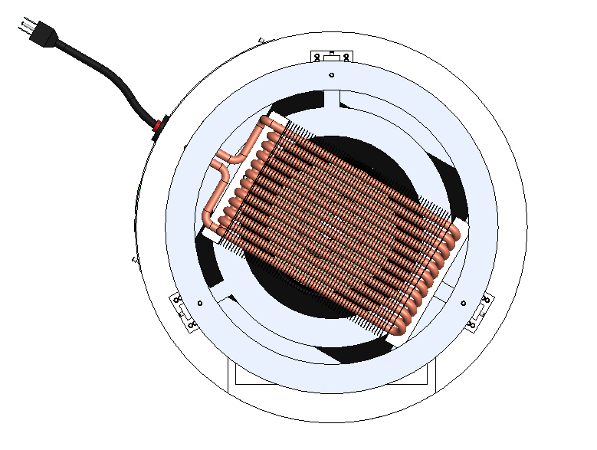

Figure : Large vs small condenser coil

The coil banks change in size due to the cooling capacity the system must output. Additionally, the size of the condenser coil is changed as a function of the outdoor temperature. This change in coil bank size also changes the overall mass of the coils and therefore changes the forces on their respective support plates. The thickness of these plates also changes as the forces change however the change is quite small and not visible in the renders.

# Discussion and critical review

The air colling and filtration device that was designed can produce up to 1500W of cooling power. It can also operate when no external power is available and filters PM2.5 from the air in the room. It meets all the criteria; however, its portability could be improved by optimizing the coil banks to weigh less. The current unit sits on wheels, so it can easily be maneuvered around the current floor it is on, but it would be difficult to move it up or downstairs without the assistance of another person.

The filters used in this design are based on those manufactured by Dyson. For this unit, it is suggested that the filters be changed every eight months; however, Dyson suggests the filters be changed everyone 12 months [7]. Eight months was recommended because it is assumed that using the unit in a home near a wildfire will cause the filter to build up filter cake faster. This is only an estimate, and testing of the filter would have to be done in wildfire-like conditions to know how long the filter would last before it needs to be changed.

Assumptions regarding the permeability of the filter were made to estimate a drag force value felt by the filter. It was assumed that the maximum pressure drop across the filter would be 500Pa, and with this, a minimum permeability was calculated. Data from a study using clean HEPA filters was used to estimate a clean filter permeability value. It was assumed that the relationship between pressure drop and permeability was linear and inversely proportional. Testing in wildfire-like conditions would have to be completed to know the actual permeability values and how these values change with filter use.

The calculations in the refrigeration cycle assume both the compression and expansion processes are both isentropic [8]. In reality, compression will absorb some energy and as such, an isentropic efficiency should be used to find a more accurate compressor work value.

Through modelling of the room, its construction and an assumed outdoor temperature, a maximum heat infiltration rate was estimated to be 1.3kW. The unit was then designed to cool at a rate of 1.5kW to ensure sufficient cooling, which is approximately 5100 BTU. This colling rate allowed for a smaller compressor and smaller coils which allowed the unit to be portable; however it is lower than most portable and window air conditioner units on the market today. This cooling rate could likely be increased with a more sophisticated fin and coil design geometry.

The analysis of the vertical support posts included analyzing bearing failure, buckling and bending failure; however other failure modes could occur as section failure, shear out and transverse splitting. Additionally, only the bending due to the moments was accounted for when calculating the bending stresses. In reality, the vertical forces due to the bolts would combine with these moments and contribute to these bending stresses. This analysis could be improved by looking at these other failure modes and accounting for the vertical loads when calculating the bending stresses. Finally, the structural analysis of the support plates has been simplified extensively to allow for hand calculations of the stresses. For a more comprehensive and accurate analysis of these plates, an FEA study should be completed to understand the actual stresses and strains within the part.

The design currently allows for one setting and does not allow for a low, medium or high setting for the cooling and filtration rate. Additionally, it does not allow the air filtration system to run independently of the air cooling system. The unit could be improved by adding a control panel that allows for a high, medium and low setting and an on-off switch for the cooling system. The different settings would be modulated by changing the compressor and blower speeds and would cause the unit to cool the room at different rates. This would allow for shorter or longer battery life. Also, if the unit had the ability to shut off the air-cooling system, it could run for much longer on the battery pack if only the blowers are running and not the compressor. Finally, the unit does not currently include a thermostat. By connecting the control panel to a thermostat the unit would have the ability to operate until the thermostat reads the desired temperature and then tell the unit to shut off.

# References

|  |  |
| --- | --- |
| [1] | Engineering ToolBox, "Aluminum Alloys - Mechanical Properties," 2008. [Online]. Available: https://www.engineeringtoolbox.com/properties-aluminum-pipe-d_1340.html. [Accessed Nov 2021]. |
| [2] | Engineering Toolbox, "Engineering Materials," 2008. [Online]. Available: https://www.engineeringtoolbox.com/engineering-materials-properties-d_1225.html. [Accessed Nov 2021]. |
| [3] | R. C. J. a. K. M. Marchek, Machine Design, John Wiley & Sons, Inc, 2006. |
| [4] | thomasnet, "All About 6061 Aluminum (Properties, Strength and Uses)," 2021. [Online]. Available: https://www.thomasnet.com/articles/metals-metal-products/6061-aluminum/]. . [Accessed Nov 2021]. |
| [5] | Matmatch GmbH, "Yield Strength of Plastics – Basic principles, the Tensile Test and Material Property Table," 2021. [Online]. Available: https://matmatch.com/learn/property/yield-strength-of-plastics. [Accessed Nov 2021]. |
| [6] | T. Rogers, "All you need to know about polypropylene," Dec 2014. [Online]. Available: https://www.creativemechanisms.com/blog/all-you-need-to-know-about-polypropylene.-part-2. [Accessed Nov 2021]. |
| [7] | Dyson , "Replacement air purifier filters," 2021. [Online]. Available: https://www.dysoncanada.ca/en/air-treatment/shop-all-air-purifier-filters. [Accessed Nov 2021]. |
| [8] | R. W. T. C.Welch, Air Conditioning System Design, Butterworth-Heinemann, 2017. |
| [9] | San Ace, "MiSumi," 2021. [Online]. Available: https://us.misumi-ec.com/vona2/detail/222005836413/. [Accessed Oct 2021]. |
| [10] | Rigid HVAC, "48V Mini Compressor," 2021. [Online]. Available: https://www.rigidhvac.com/48v-mini-compressor. [Accessed Oct 2021]. |
| [11] | American Electric, "48V 30AH RECTANGULAR LITHIUM-ION BATTERY PACK," 2021. [Online]. Available: https://www.american-electric.co/products/48v-30ah-rectangle-lithium-ion-battery-pack. [Accessed Nov 2021]. |
| [12] | Caster Depot, "GLAP 100 GEL - Black," 2021. [Online]. Available: https://www.casterdepot.com/schioppa/glap-100-gel-black?fbclid=IwAR0tBaI29iS91CHnywNn31a8N9753QuXbE21OeM__7o6Y73RoT9BKkJSv6s. [Accessed Nov 2021]. |
| [13] | McMaster Carr, "McMaster Carr," 2021. [Online]. Available: https://www.mcmaster.com. [Accessed Nov 2021]. |
| [14] | I. R. J. W. E. T. a. A. H. Al-Attar, "he Effect of Pleat Count and Air Velocity on the Initial Pressure Drop and Fractional Efficiency of HEPA Filters," Filtech Exhibitions, Loughborough, 2009. |
| [15] | M. K. &. G. Krammer, "The Permeability Distribution (PD) Method for Filter Media Characterization," *Aerosol Science and Technology,* vol. 42, no. 6, pp. 433-444, 2008. |
| [16] | Engineers Edge, "HEPA Filter Pressure drop considerations," Engineers Edge, 2021. [Online]. Available: https://www.engineersedge.com/filtration/hepa_filter_pressure_drop_considerations.htm. [Accessed Oct 2021]. |
| [17] | I. R. J. W. E. T. a. A. H. Al-Attar, "The effect of pleat count and air velocity on the initial pressure drop and fractional efficiency of HEPA filters," Filtech Exhibitions, 2009. |
| [18] | A. J. L. L. C. Félicie Theron, "Numerical and experimental investigations of the influence of the pleat geometry on the pressure drop and velocity field of a pleated fibrous filter.," *Separation and Purification Technology,* no. 182, pp. pp.69-77, 2017. |
| [19] | A. Bhatia, "CED Engineering," [Online]. Available: https://www.cedengineering.com/userfiles/HVAC%20-%20How%20to%20Size%20and%20Design%20Ducts%20R1.pdf. [Accessed Nov 2021]. |
| [20] | G. L. Hammock, "Cross-Flow, Staggered-Tube Heat Exchanger Analysis for High Enthalpy Flows," University of Tennessee, Knoxville, Knoxville, 2011. |
| [21] | Thermaflex, "Flexible duct application information," 2021. [Online]. Available: https://www.thermaflex.net/wp-content/uploads/2016/03/Thermaflex-Air-Flow-and-Air-Friction-Brochure.pdf. [Accessed Nov 2021]. |

1. Instructions for running GUI

Some things to consider when running the SolidWorks is that the casing takes an exceptionally long time due to the meshing. We have provided an assembly without the casing, consider building the SolidWorks without the casing if you run into this problem for the parameterizations. Additionally, the meshing holes in the casing were not able to get parametrized due to the long computational times, therefore they will not adjust with the overall height of the unit.

The number of evaporator coils in the SolidWorks does not reflect the actual number of evaporator coils in the MATLAB. This is because the SolidWorks was built without the proper spacing between evaporator coil rows and was realized too late in the process. To adjust for this, the MATLAB code uses a factor of 3 to divide the number of evaporator coil rows.

1. Component parameterization flowcharts



Figure B.1: Condenser coil flow chart



Figure B.2: Evaporator coil flow chart

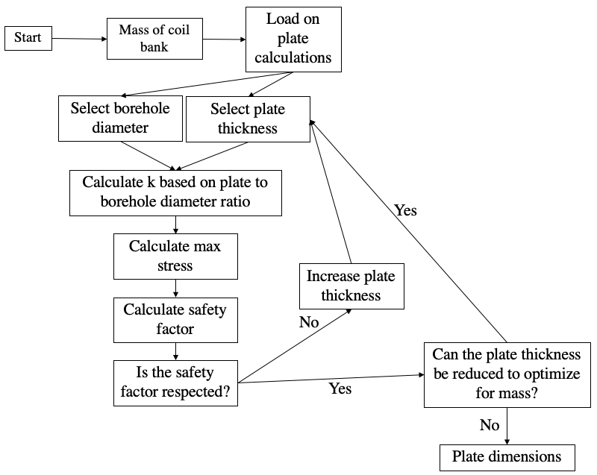

Figure B.3: Support plate flow chart

1. Design code

## Text Description automatically generated with low confidenceC.1 Design_code: (Main function for Design_code)

*Figure C.1: Design code page (1/5)*

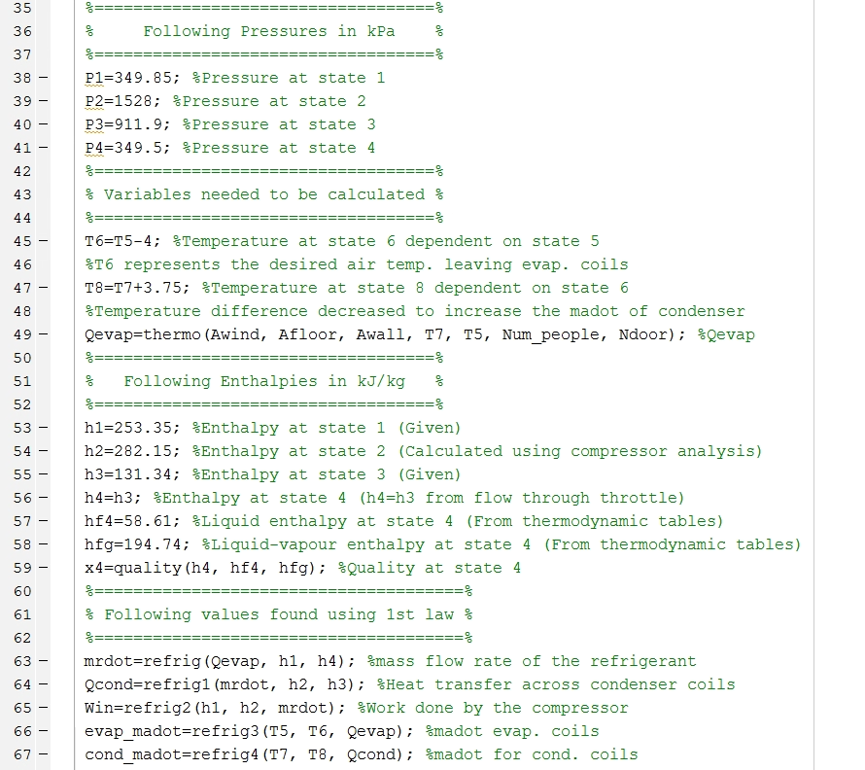

*Figure C.2: Design code page (2/5)*

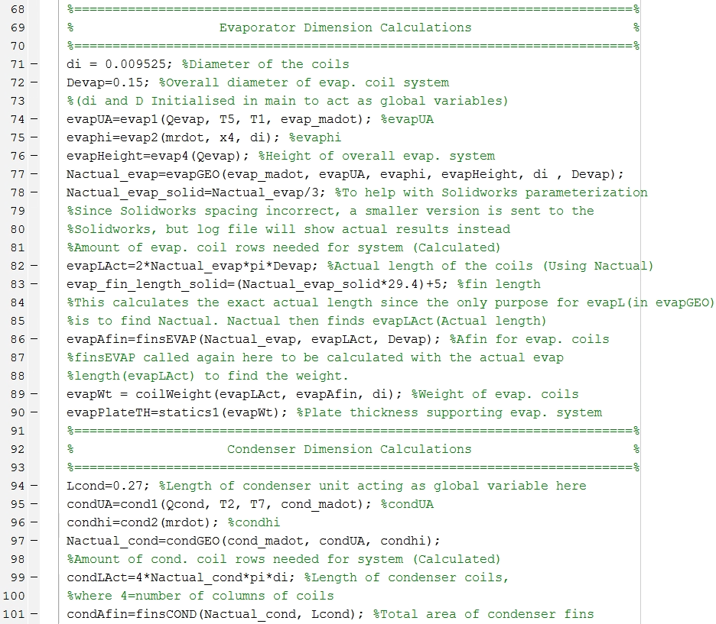*Figure C.3: Design code page (3/5)*

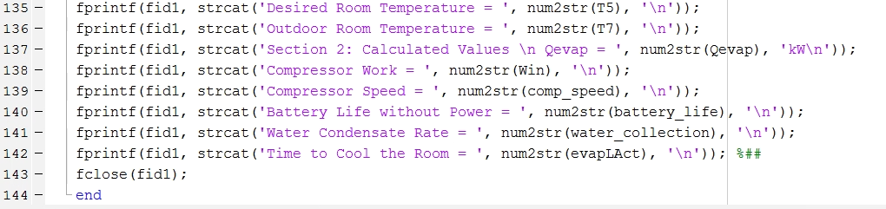*Figure C.4: Design code page (4/5)*

*Figure C.5: Design code page (5/5)*





*Figure C.6: Heat transfer across evaporator unit function*

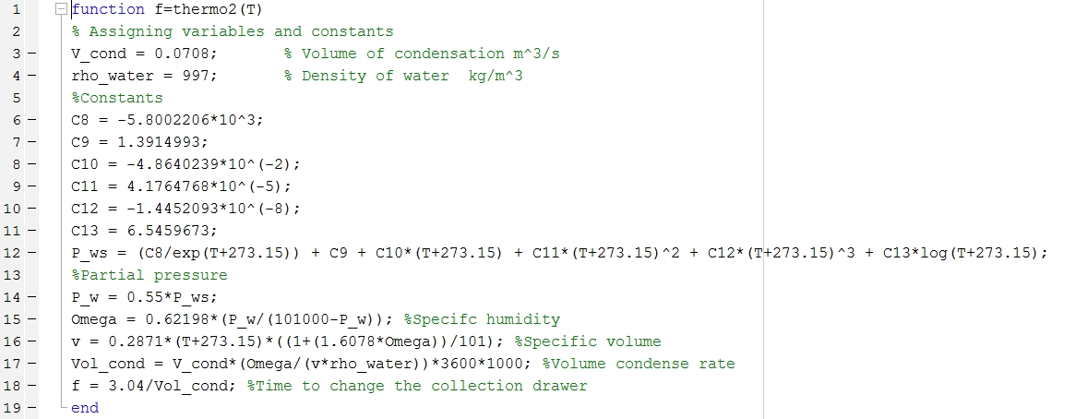

*Figure C.7: Heat transfer across condenser unit function*

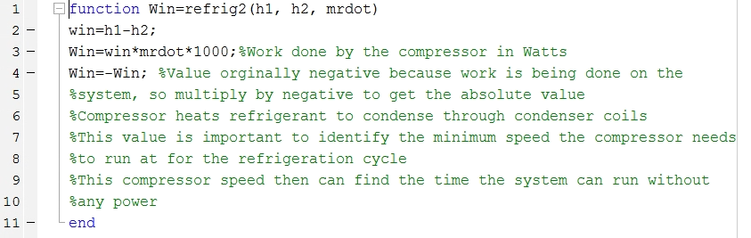

*Figure C.8: Work done on System function*

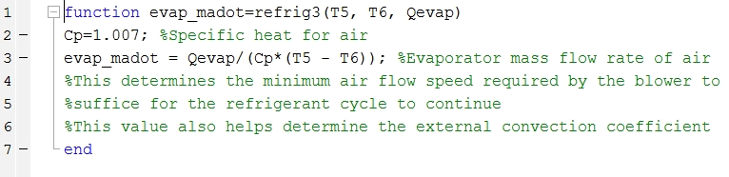*Figure C.9: Evaporator mass flow of air function*

*Figure C.10: Condenser mass flow of air function*

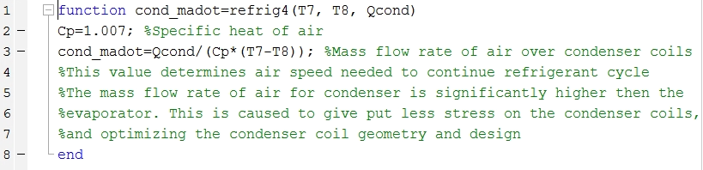

*Figure C.11: Evaporator Overall Heat Coefficient function*

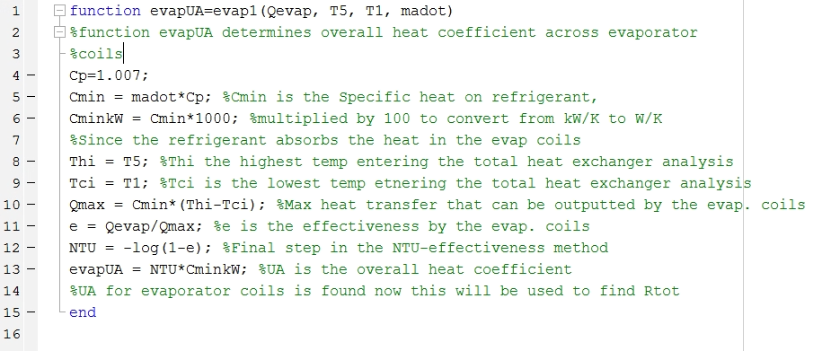

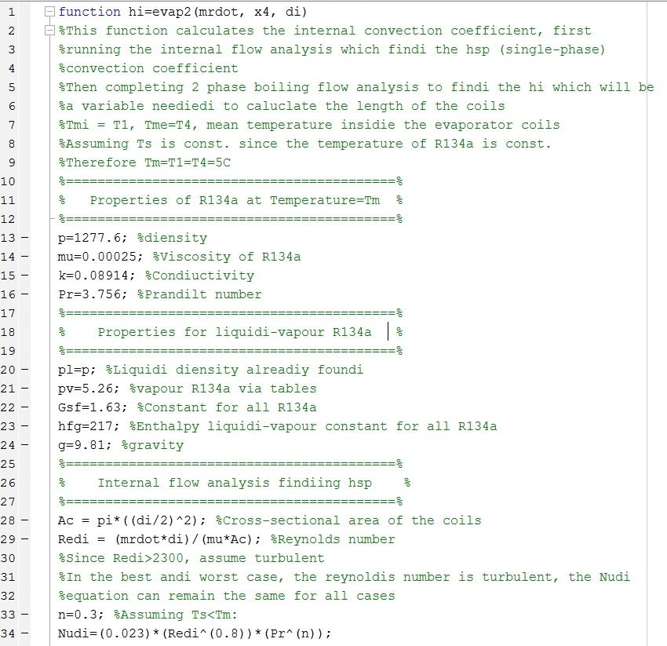Figure C.12: Evaporator Internal Convection Coefficient function (1/2)

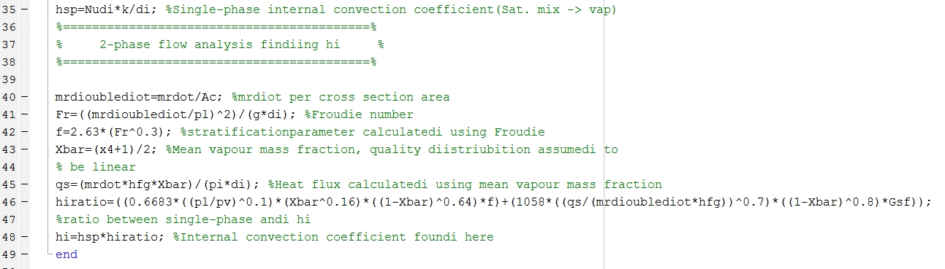

Figure C.13: Evaporator Internal Convection Coefficient function (2/2)

Figure C.14: Evaporator Overall Height function

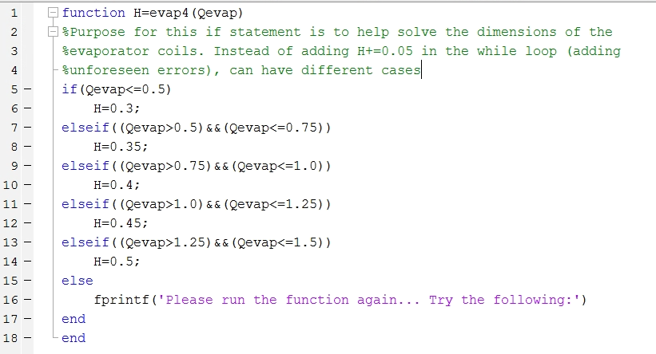

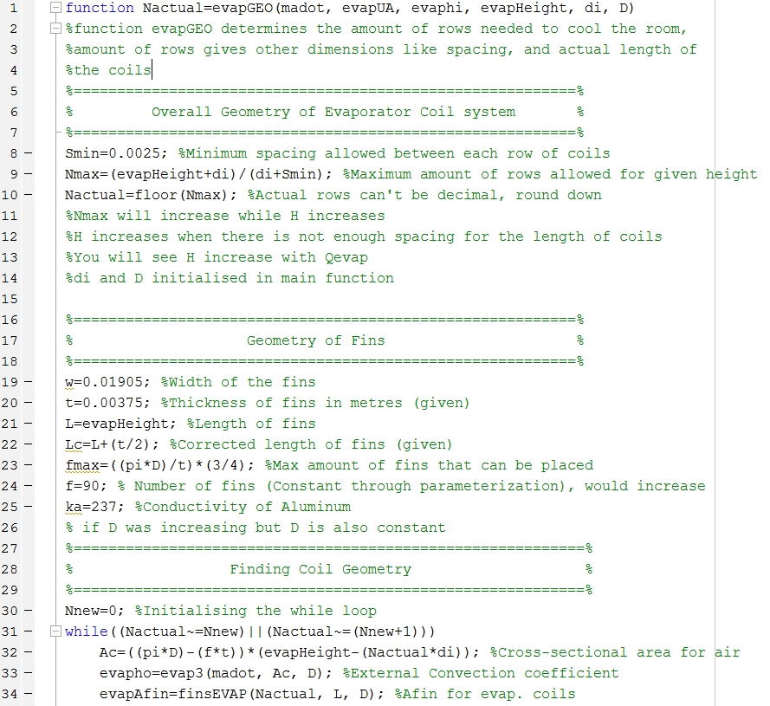

Figure C.15: Number of Evaporator coils function (1/2)

Figure C.16: Number of Evaporator coils function (2/2)

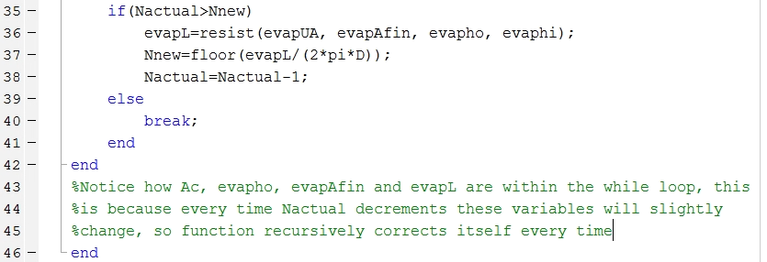

Figure C.17: External Convection Coefficient

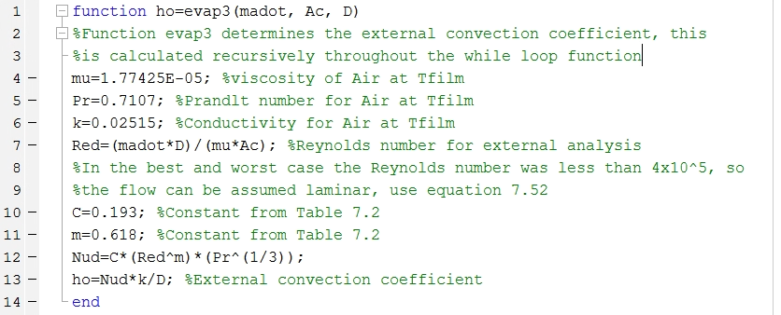

Figure C.18: Evaporator fins total area function

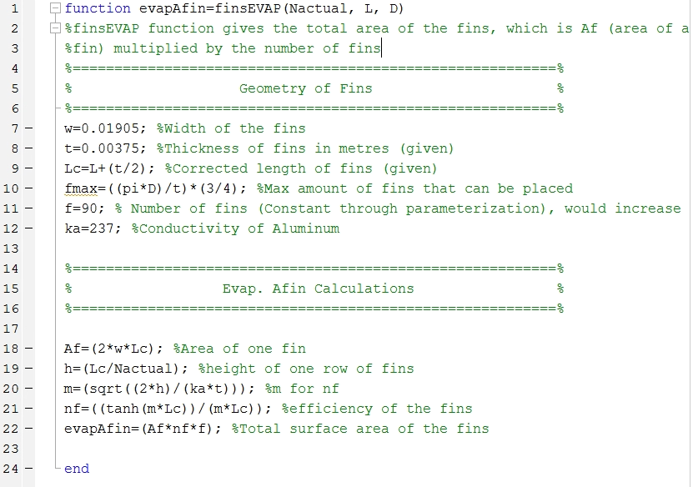

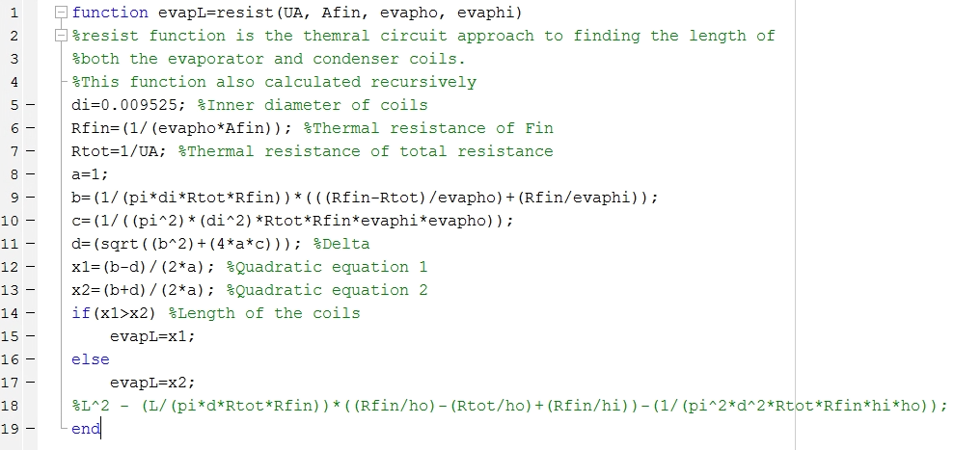

Figure C.19: Evaporator Length function

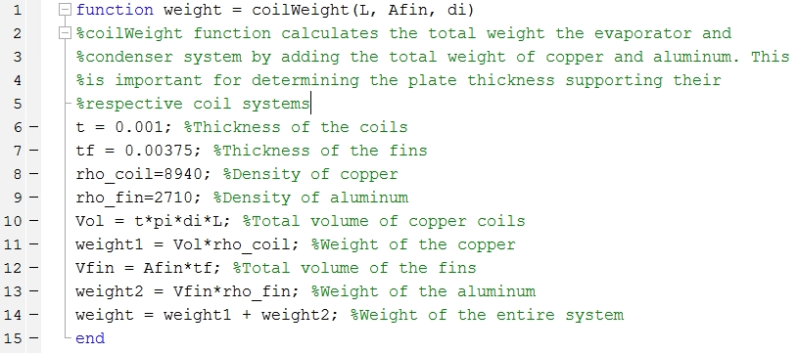

Figure C.20: Evaporator and condenser weight function

Figure C.21: Evaporator plate thickness function

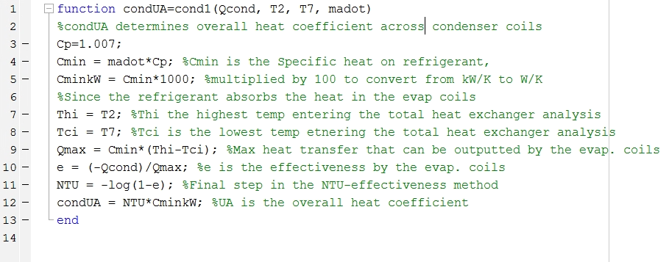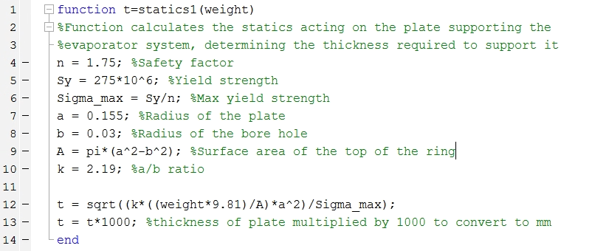

Figure C.22: Condenser overall heat coefficient function

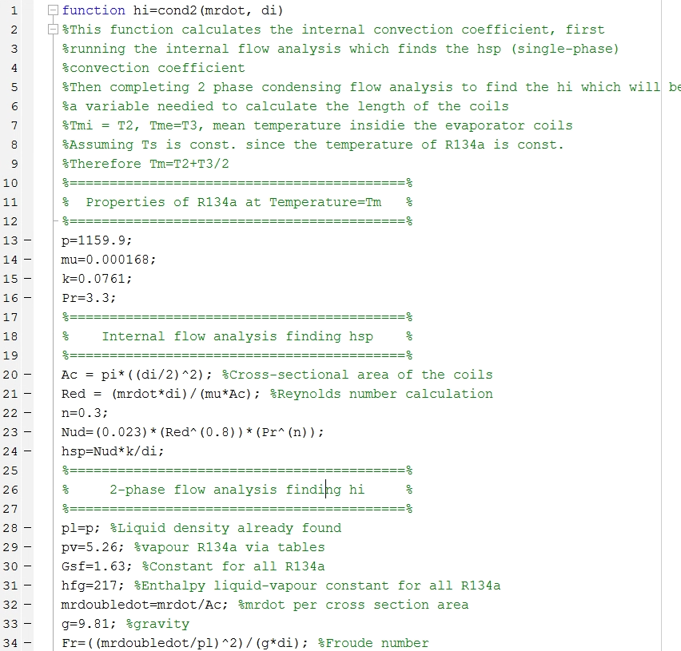

Figure C.23: Condenser internal convection coefficient function (1/2)

Figure C.24: Condenser internal convection coefficient function (2/2)

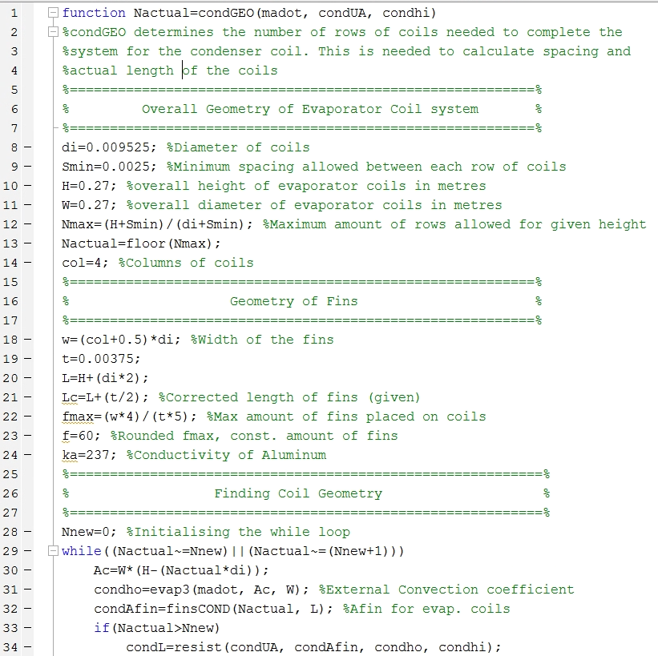

Figure C.25: Condenser number of rows function (1/2)

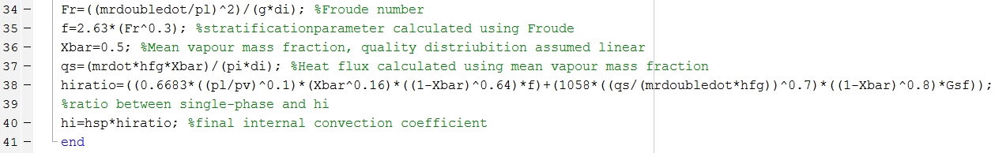

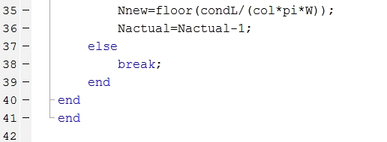

Figure C.26: Condenser number of rows function (2/2)

Figure C.27: Condenser total area of fins function

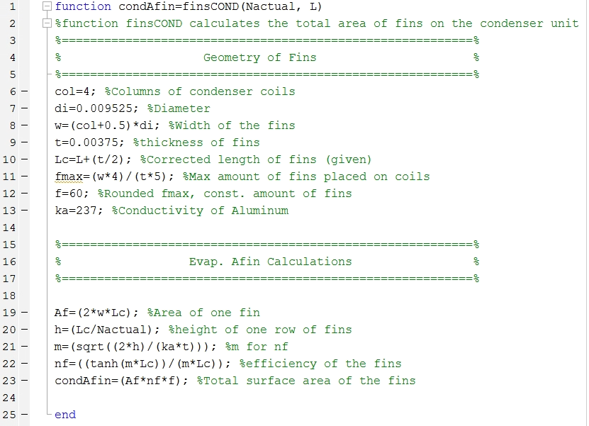

Figure C.28: Condenser plate thickness function

Figure C.29: Compressor speed function

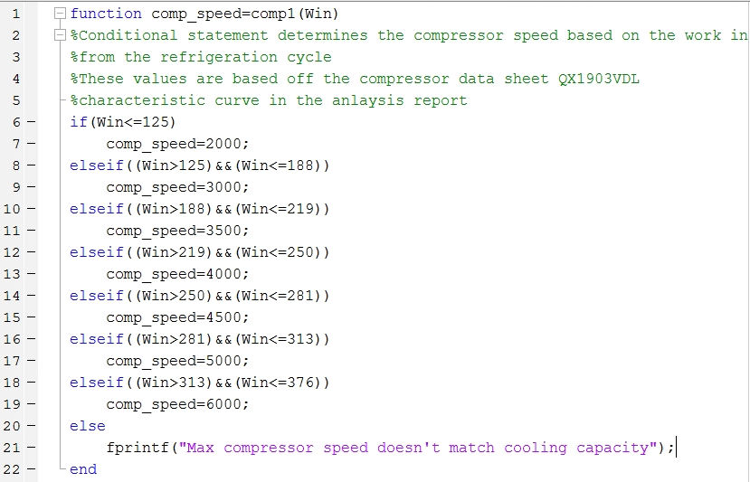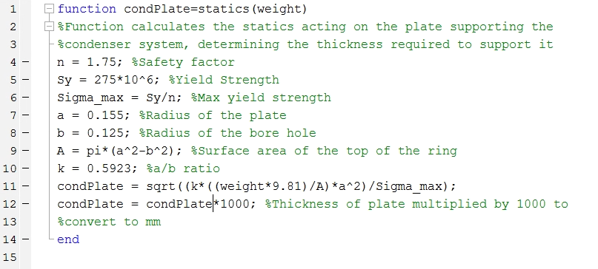

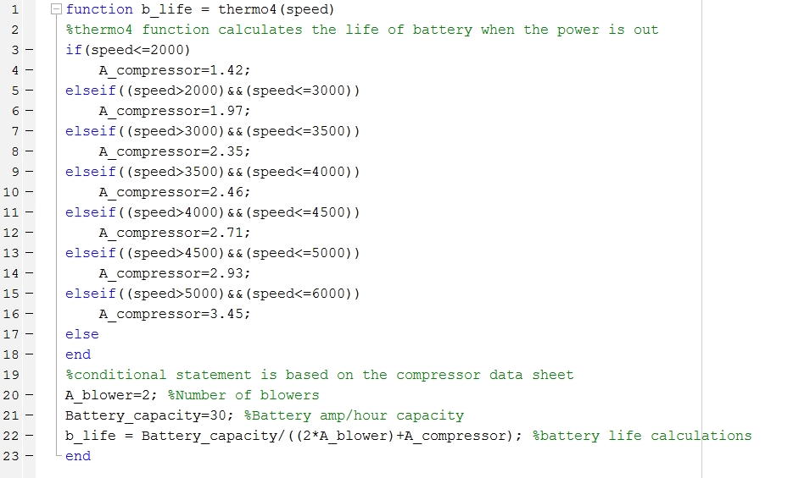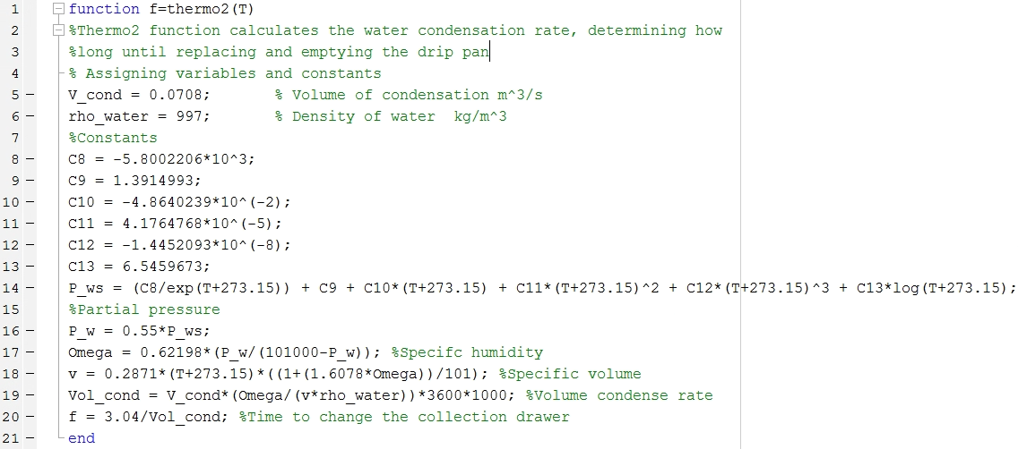Figure C.30: Water Collection rate function

C.31: Battery life function

1. Datasheets



*Figure D.1: Blower Datasheet 1* [9]

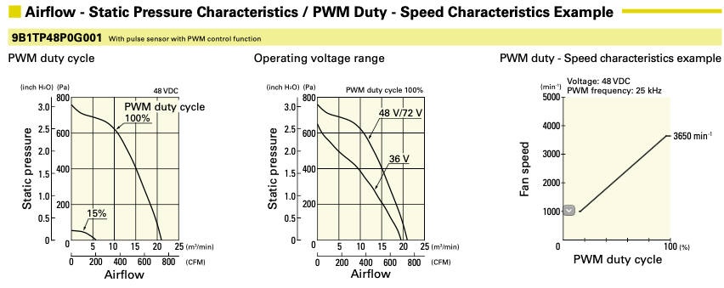

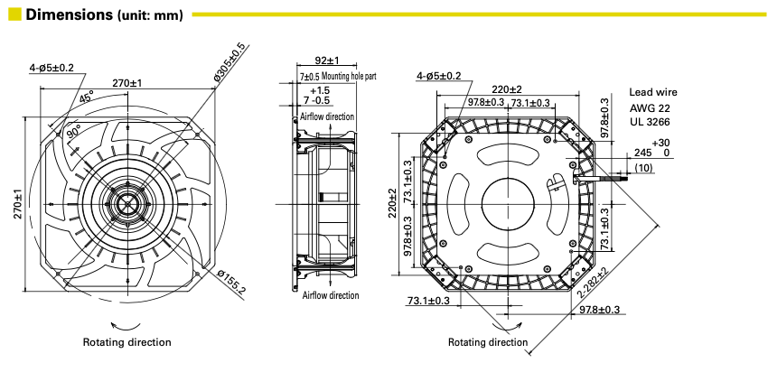

*Figure D.2: Blower Data sheet 2* [9]

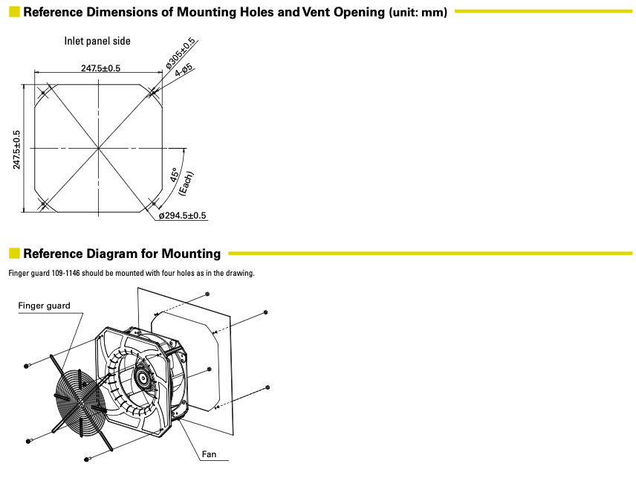

*Figure D.3: Blower Data sheet 3* [9]



*Figure D.4: Compressor datasheet 1* [10]



*Figure D.5: Compressor datasheet 2* [10]



*Figure D.6: Compressor datasheet 3* [10]



*Figure D.7: Compressor datasheet 4* [10]

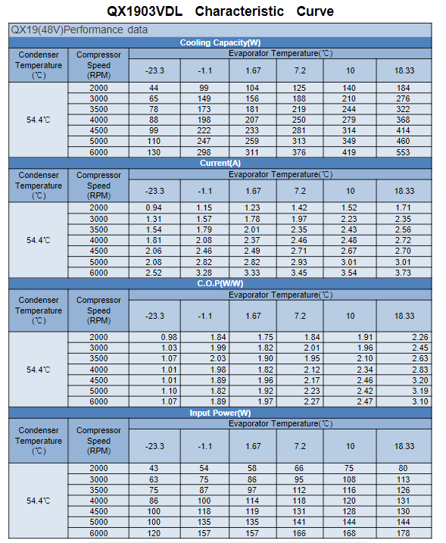

*Figure D.8: Compressor datasheet 5* [10]

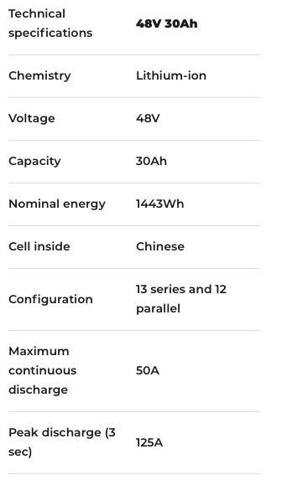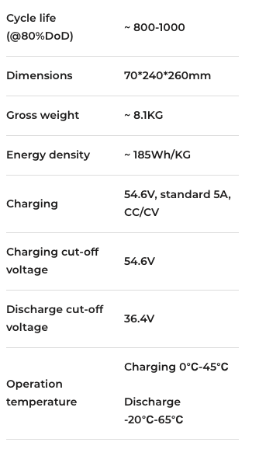

*Figure D.9: Battery datasheet* [11]

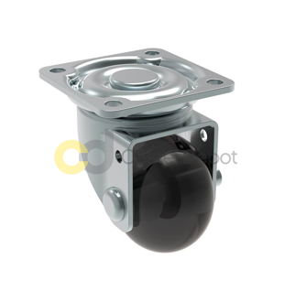

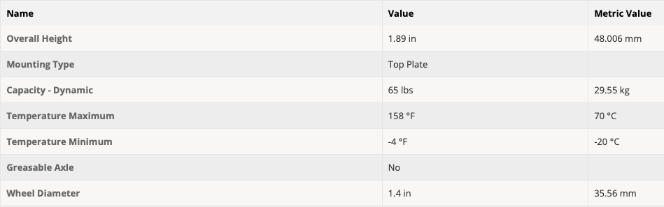



*Figure D.10: Caster datasheet 1* [12]

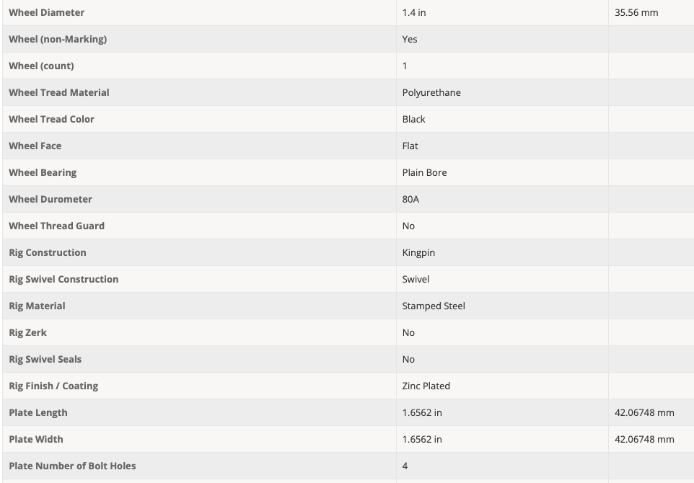

*Figure D.11: Caster datasheet 2* [12]

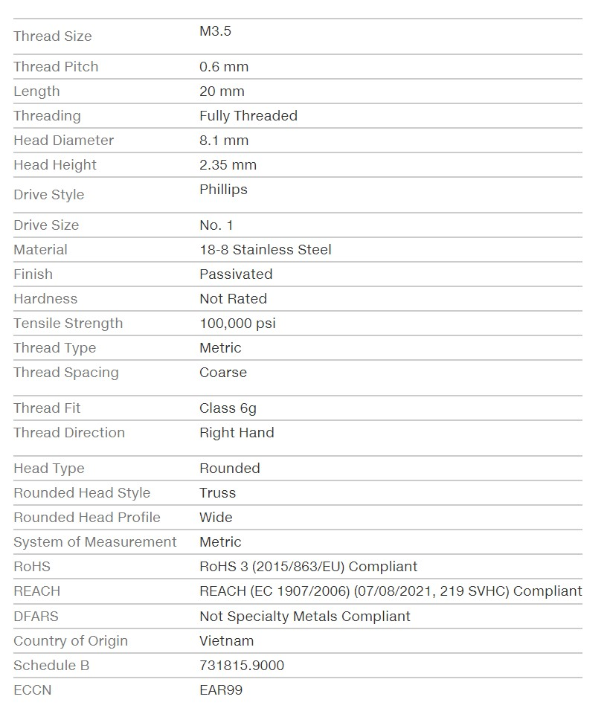

*Figure D.12: Bolt datasheet* [13]

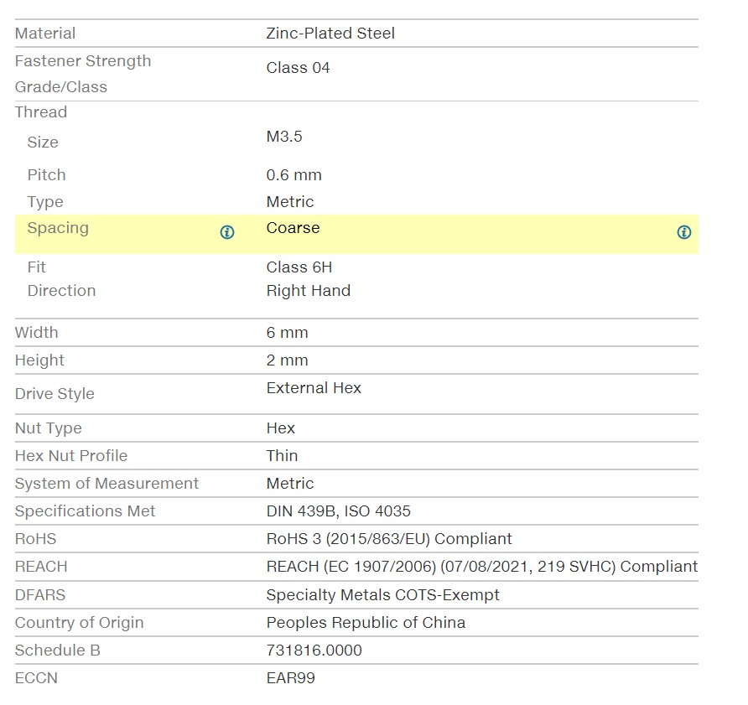

*Figure D.13: Nut data sheet* [13]

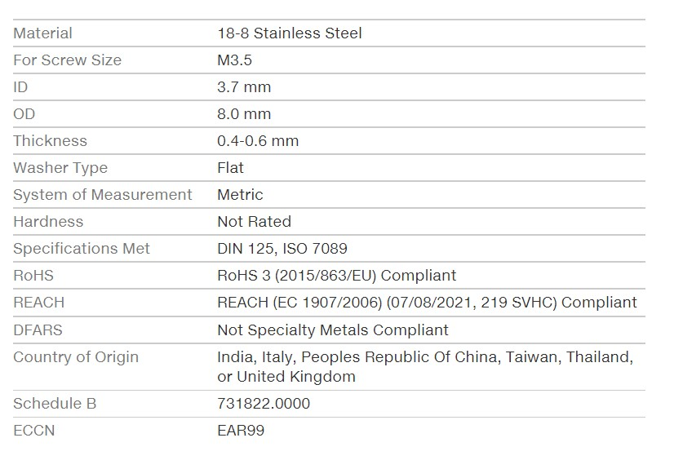

*Figure D.14: Washer data sheet* [13]

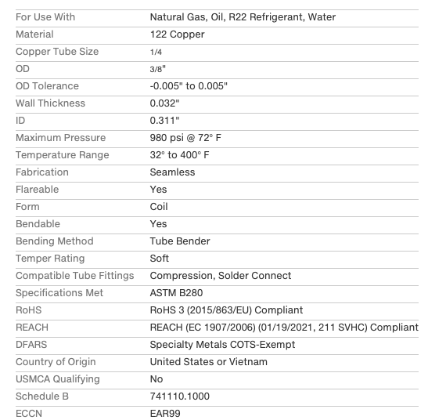

*Figure D.15: Refrigerant tubing data sheet* [13]

1. Additional material

Drag force on the filter

Due to the fibrous nature of the filter, the air being pulled through the filter will experience some resistance. Therefore, the blower pulling the air through the filter must overcome this pressure drop. The pressure drop across the filter must be calculated to ensure the filter mounts are strong enough to support this drag force. Darcy’s law can be used to model the flow of a fluid through a porous medium and is calculated using the following equation [14].

$$Q=\frac{k⋅A}{μ⋅L}∆p$$

In this equation, Q is the volumetric flow rate of the air in m3/s, A area of the filter medium in m2, k is the permeability of the medium in m2, is the dynamic viscosity of the fluid in Pa s, L is the thickness of the filter medium in m and ∆p is the pressure difference across the filter in Pa. The pressure drop across the filter will increase as the filter collects PM. This buildup is commonly referred to as a filter cake. As the filter cake grows, this causes an increase in pressure drop. If the filter cake is assumed to be incompressible, this relationship is linear [13]. However, sometimes an increasing slope is observed, and this is due to compression of the filter cake. Additionally, it can also be observed that the slope decreases over time, and this is due to inhomogeneities in the filter. This can happen if the filter cake does not build up evenly. There are patches of more densely packed dust collection or inconsistencies in the filter fiber due to manufacturing errors [14].

For the purpose of this modelling, the relationship between pressure drop and usage time will be assumed to be linear. This suggests that the build-up of the filter cake is linear, which means a linear decrease in permeability as pressure drop increases.

Most literature suggests that HEPA filters should be changed when they reach a pressure drop of about 500Pa [17]. Because flow rate, filter depth, filter area, and air’s dynamic viscosity are all constant, Darcy’s law can be used to calculate a minimum permeability. A pleating density of 34 pleats per 100 mm will be used. This is consistent with common HEPA filter designs. The filter will has a maximum height of 0.50m and depth of 0.01m. The circumference of the filter is 0.94m yielding about 320 pleats total. The total filter medium area is calculated below.

$$A_{T}=0.50m⋅0.01m⋅320⋅2=3.20m^{2}$$

$$k=\frac{Q⋅μ⋅L}{A⋅∆p}=\frac{ \frac{0.0708m^{3}}{s}⋅1.825⋅{10}^{-5}Pa⋅s⋅0.002m}{3.20m^{2}⋅500Pa }=1.62⋅{10}^{-12}m^{2}$$

The permeability calculated above is the minimum permeability and that of a dirty filter needing to be changed. In order to determine the range of permeability and pressure drops some approximations will be made for the clear filter. In a study conducted by Loughborough University clean HEPA filters were tested in order to determine their permeability values. In this study the rests were run at a flow rate about 2 times as much and the filter used has 9 times the area of the one in this design. This study found permeability values around 2.97x10-12 m2 [4]. Assuming the effects of change in flow rate and area are linear this would equate to a clean permeability value of 1.36x10-11m2 for the geometry of this designs filter. This value is consistent with those recorded in other literatures [4]. Darcy’s law can be used again to calculate an initial pressure drop.

$$∆p=\frac{Q⋅μ⋅L}{A⋅k}=\frac{ \frac{0.0708m^{3}}{s}⋅1.825⋅{10}^{-5}Pa⋅s⋅0.002m}{3.20m^{2}⋅1.36⋅{10}^{-11}m^{2} }=59.31Pa$$

This means the pressure drop across the filter would increase from 59.31Pa to 500Pa as the filter cake builds and the permeability decreases which is a reasonable growth. The calculations above are for the worst case sicario when the filter is 0.50 m tall. As the unit is parameterized the area of the filter will change however the permeability values will stay the same and the maximum pressure drop will remain at 500Pa. This means only the initial pressure drop when the filter is clean will change and it is inversely proportion to the area. As a result, as the filter becomes smaller the filter area decreases resulting in a higher initial pressure drop and as such the filter will reach the critical pressure drop of 500Pa sooner. This makes sense because the same volume flow of dirty air is moving through the filter but there is less pore space to collect the PM.

Pressure losses in the duct system

As the air moves through the system for both the evaporator coil and the condenser coil, it is important to understand the pressure losses experienced by the air. This will allow for proper blower and ducting design. The two blowers will be modelled separately, but the principals are the same. Pressure losses can be due to friction between the air and the duct walls, dynamic losses due to changes in air velocity and direction and equipment losses due to air resistance over filters or coils [6]. The system's static pressure must be smaller than that generated by the blower and includes negative static pressures on the pull side of the fan and positive static pressures on the push side of the fan.

Blower 1

The airflow path in blower one can be modelled as the figure below. 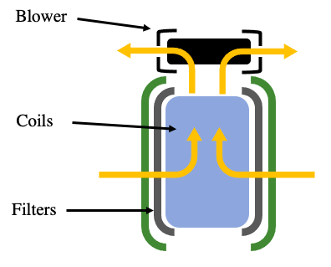

Figure E.1: Airflow path of the evaporator coil

As discussed above, the pressure loss due to the filter (PLfilter) at maximum filter cake is 500Pa. The pressure loss due to the evaporator coil is quite complex to calculate. It can be evaluated using the Kay and London pressure drop model; however this requires computational fluid dynamics (CFD) and is beyond the scope of this project [6]. A pressure loss of 100 Pa will be used (PLcoils). After the blower the air is exhausted out at 360 degrees through a grate of negligible pressure loss. The total static pressure (TSP) of the path is calculated below.

$$TSP=PL_{filter}+PL_{coils}=500Pa+ 100Pa=600Pa$$

Therefore for this blower it experiences a static pressure of 600Pa which is lower than the maximum static pressure at 150 CFM as shown in the figure below.

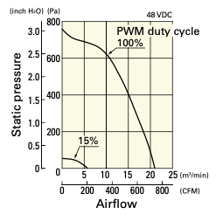

Figure E.2: Characteristic curve for blower [8]

Blower 2

The second blower is a more complex scenario as it has both an inlet and outlet duct as well as coils. This air path will be modeled as the following.

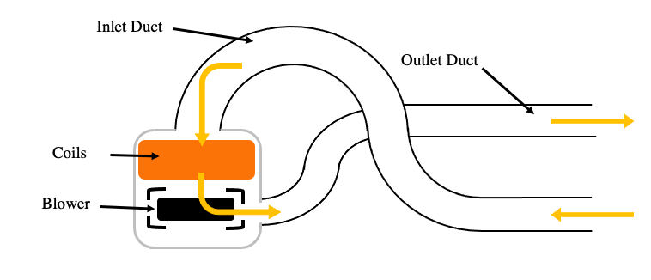

Figure E.3: Air flow path for the condenser coil

The air will first experience pressure losses in the inlet duct, the coils and then the outlet duct. The pressure losses in the ducts are relative to the length of the duct and the number of bends it makes. It will be assumed both ducts have 0.5 meters of straight duct and that the inlet duct makes three 90 degree bends and the outlet duct makes two 90 degree bends. Typically duct manufactures supply pressure loss tables to ensure the ducts are used in an appropriate setting. In this system 4” flexible ducts from thermaflex will be used and the pressure loss data for these ducts at various diameter can be seen below.

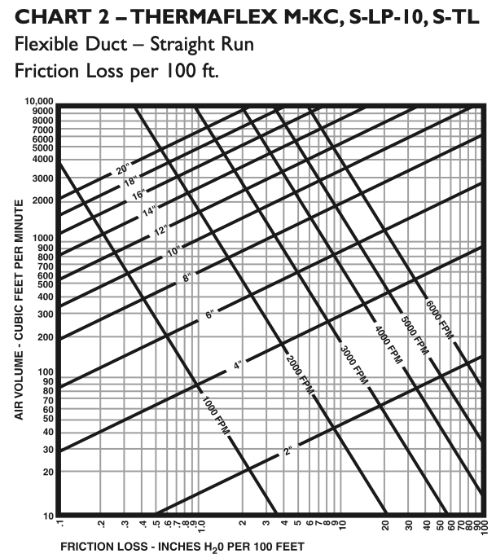

Figure E.4: Friction loss data for 4" flexible duct [9]

Using this table with a CFM of 150 the pressure loss factor is approximately 2.5 inches of H20 per 100 feet of duct or 20.74 Pa per meter. For the 90 degree bends the following relation must be calculated where R is the centre line bend radius of the duct and D is the diameter of the duct. The bends will have an assumed centre line bend radius of 8”.

$$\frac{R}{D}=8"\text{/4"}=2$$

The figure below can be used to find the equivalent length for a R/D of 2.

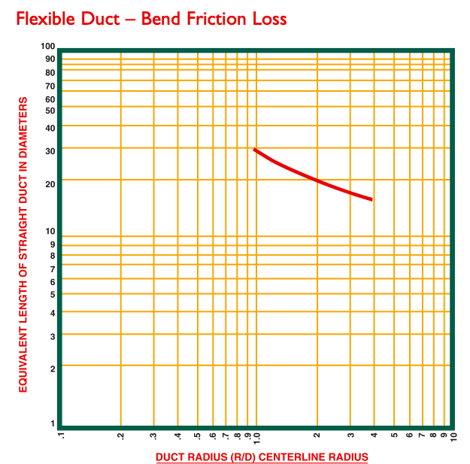

Figure E.5: Geometric relation for friction losses in duct bends [9]

Locating the intersection of R/D and 2 and the line yields an equivalent length of 20 diameters of 4” duct which is 160” or 4.06 m per 90 degree bend. The total pressure lost in the ducts is then calculated below where PLstraight is the pressure loss due to straight sections of duct and PLbends is due to the bends in the ducts.

$$SP=PL_{straight}+PL_{bends}=20.74Pa⋅0.50m⋅2+5⋅4.06m⋅20.74Pa=441.76 Pa$$

As stated above, solving for the pressure loss over the coils is complex task that requires work outside the scope of this project. The same assumption of 100Pa will be used here. The total pressure loss is calculated below.

$$TSP=441.76Pa+100Pa=541.76Pa$$

As shown in the figure above this is again lower than the maximum static pressure capable by the blower at 150 CFM. This proves that the blower is sufficient.

Cost of materials

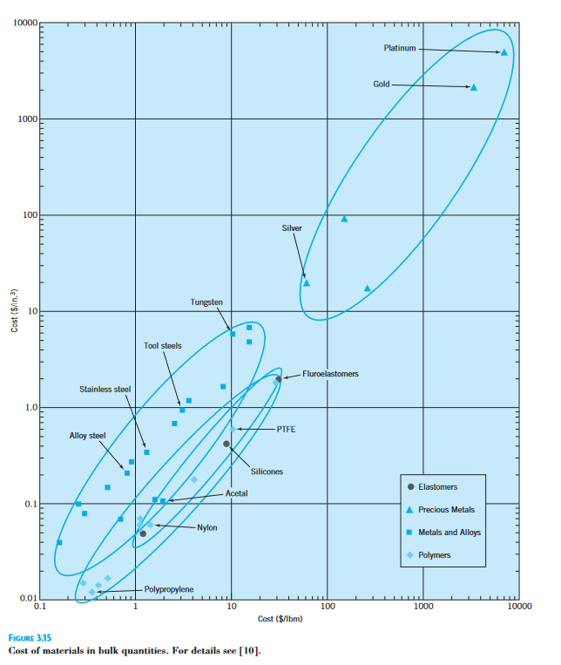

Figure E.6: Cost of various metals [1]

Cross-section of the unit

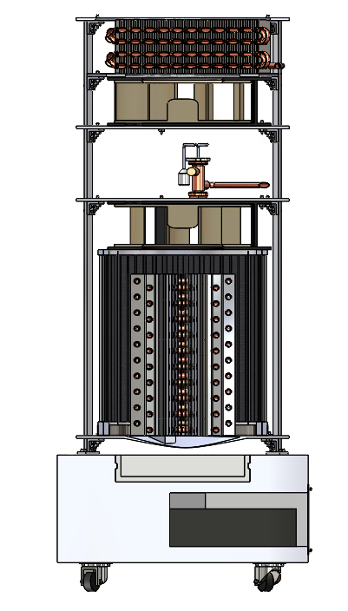

Figure E.7: Cross-section of internal components